Hotel booking for attending
17th International Hydrogen & Energy Symposium
The symposium will be held in Days Hotel by WYNDHAM （戴斯温德姆酒店）located at No. 2 Honghu St., Daoli Dist., Harbin, China. You can check the hotel’s information via https://hotels.ctrip.com/hotels/detail/?hotelId=115644681.
There is also a hotel named DaysInn Hotel by WYNDHAM （戴斯精选温德姆酒店）very nearby Days Hotel by WYNDHAM. The guests in the DaysInn Hotel have breakfast in the Days Hotel by walking outside for 1~2 minutes.
Two hotels could be booked in advance by filling the following form and sending the form to zhangjinqiu@hit.edu.cn before Feb. 1st, 2025.
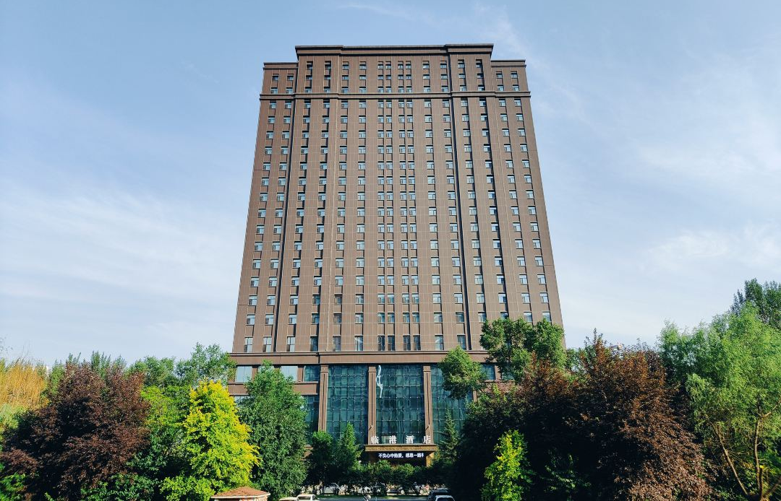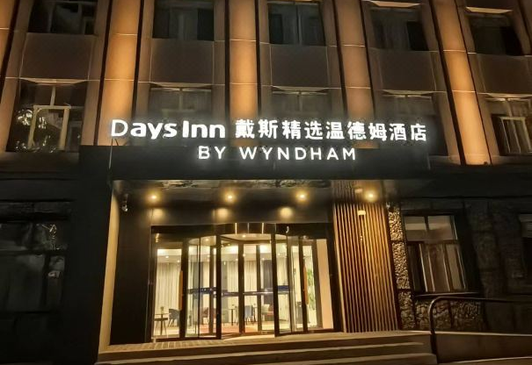
Days Hotel by WYNDHAM DaysInn Hotel by WYNDHAM
Guests’ Name: (1) (2) Tel:
Arrival Date： Departure Date：
Hotel | Room | Feb. 15 | Feb. 16 | Feb. 17 | Total
Days  Hotel by WYNDHAM  戴斯  温德姆酒店 | King size bed room with one bed  大床房 | CNY 550  Book □  Not Book □ | CNY 350  Book □  Not Book □ | CNY 350  Book □  Not Book □ | 1 Night □  2 Nights □  3 Nights □
Days  Hotel by WYNDHAM  戴斯  温德姆酒店 | Queen size bed room with two beds  双床房 | CNY 550  Book □  Not Book □ | CNY 350  Book □  Not Book □ | CNY 350  Book □  Not Book □ | 1 Night □  2 Nights □  3 Nights □
Days  Hotel by WYNDHAM  戴斯  温德姆酒店 | Family room with two beds  家庭房 | CNY 600  Book □  Not Book □ | CNY 400  Book □  Not Book □ | CNY 400  Book □  Not Book □ | 1 Night □  2 Nights □  3 Nights □
Days  Hotel by WYNDHAM  戴斯  温德姆酒店 | Suit room with one bed  套房 | CNY 700  Book □  Not Book □ | CNY 500  Book □  Not Book □ | CNY 500  Book □  Not Book □ | 1 Night □  2 Nights □  3 Nights □
DaysInn Hotel by WYNDHAM  戴斯精选  温德姆酒店 | King size bed room with one bed  大床房 | CNY 450  Book □  Not Book □ | CNY 300  Book □  Not Book □ | CNY 300  Book □  Not Book □ | 1 Night □  2 Nights □  3 Nights □
DaysInn Hotel by WYNDHAM  戴斯精选  温德姆酒店 | Queen size bed room with two beds  双床房 | CNY 450  Book □  Not Book □ | CNY 300  Book □  Not Book □ | CNY 300  Book □  Not Book □ | 1 Night □  2 Nights □  3 Nights □
DaysInn Hotel by WYNDHAM  戴斯精选  温德姆酒店 | Family room with two beds  家庭房 | CNY 500  Book □  Not Book □ | CNY 350  Book □  Not Book □ | CNY 350  Book □  Not Book □ | 1 Night □  2 Nights □  3 Nights □

